WW18-19 2004 450GX Optimization Status

Finished power routing. Split power plane took more time to support 1.2V and 3.3V rails. Routed a handful of signals and still not sure if I can route all signals in 6 layers. Even 8 layers may not be the full answer since via density near FPGA is getting pretty high.

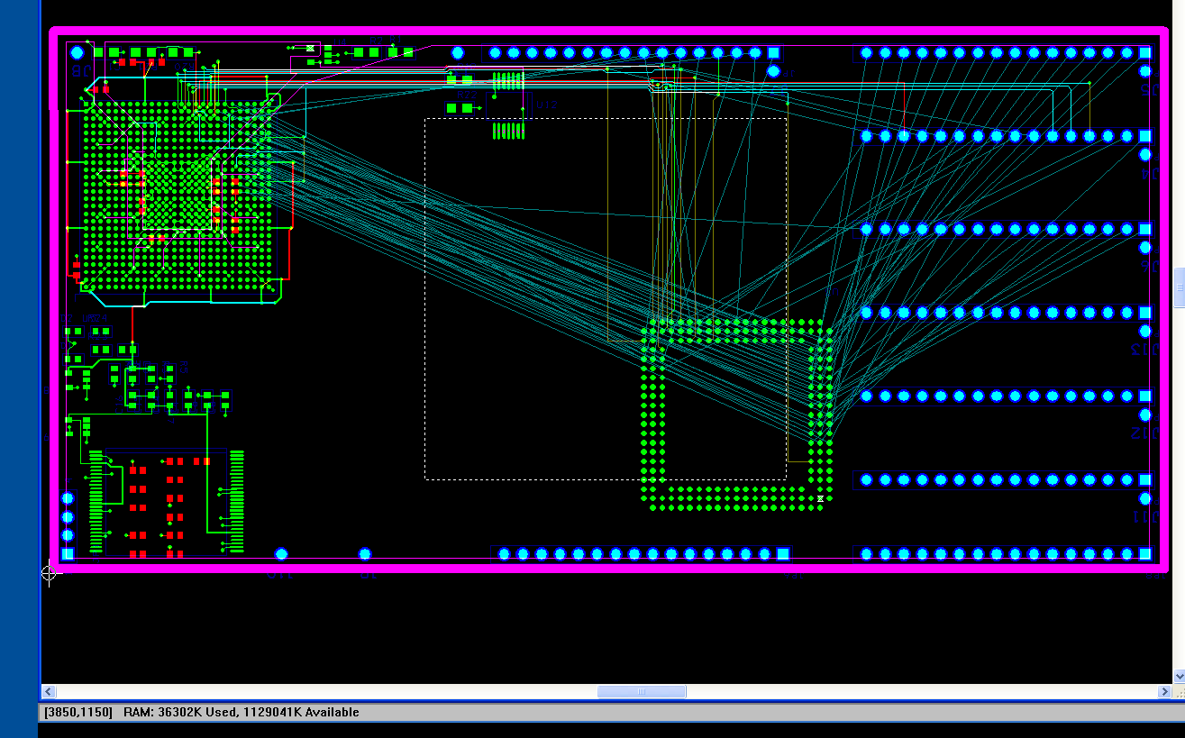

There are four caps under the BGA for core 1.2V and 4 caps for the 3.3V IO voltage levels. I hope this is enough, and can stack capacitors in parallel if needed.

I am starting to consider implementing only one FPGA at a time to reduce risk. Instead of swapping out both data control and data path chips, only swap out data control first and get that working before swapping out data path chip. This would allow more time researching deeper chipset cache ideas.

Hours spent this week: ~10

Comments, suggestions, questions are certainly welcome at steen_tech@yahoo.com

